
Physics and Astronomy
University of Missouri Fall 2021

Communiqué
News from the Chair

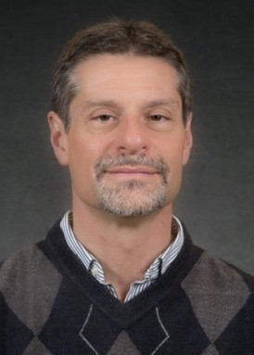
Dear Alumni, Colleagues and Friends,
Greetings from the Department of Physics and Astronomy. The fall of 2021 provided an opportunity to open up after a year and a half of on-line classes and meetings. The department held a student welcome in August prior to the beginning of classes and there was a thunderous turn-out. The excitement and the enthusiasm of our students was inspiring to all of the faculty who met with them. The Physics and Astronomy Graduate Student Association (PAGSA) held its first department picnic in two years and it gave the start of the fall semester a welcomed sense of normalcy.
Despite the pandemic, our semester course enrollments have held steady and the enrollment in our summer courses has climbed steadily every year, thanks to the faculty who have done outstanding work in developing these courses and in making them popular with the students. We also expanded our semester-based offering of courses for non-majors with two well-received new additions. Prof. Haojing Yan’s “History of Astronomy” quickly reached its enrollment cap of 100 students and Prof. Gavin King’s “Everyday Wonders: How Ordinary Things Work” (with hands-on activities in an on-line course!) immediately filled on the day that enrollment opened. Our other general education courses, “Introduction to Astronomy”, “Life and the Universe” and “Physics of Space Exploration” continue to be very well-attended, which demonstrates the importance and the centrality of Physics and Astronomy to a liberal arts education.
Our faculty, students and postdoctoral researchers have been productive in research, publishing over 120 papers per year with many appearing in high-impact journals. The faculty are diligently writing proposals for research funding, including several faculty who were successful over the past year by leveraging their expertise through collaborative proposals. Prof. Ioan Kosztin and Prof. Gavin King received funding from the National Science Foundation (NSF) for combined theoretical and experimental studies of protein interactions with membranes; and Prof. Carlos Wexler, in collaboration with engineering faculty at Missouri University of Science and Technology (Rolla), received funding
from the NSF to investigate gas storage for alternative fuel applications.
We are extremely grateful to receive two new endowments from former students of the Department of Physics and Astronomy. The estate of Benny Rose (MS’67, PhD’72) bequeathed the B. H. Rose Endowment Fund to support graduate student fellowships in the Department. Barbara (BS’70, MS’71) and Scott (MS’71) Armstrong, who first met while studying physics in our department, established the Scott A. and Barbara Schindler Armstrong Physics
Endowment. These generous gifts will benefit our students for years to come.
Four of our undergraduates participated in research internships over the summer and each of them reviewed their research accomplishments in a Colloquium presentation on October 11. Ben Krewson (Defect Dynamics and Selection for Quenched Striped Patterns), Troy Schneider (Structured Glass-Ceramic Scintillators), Lauryn Williams (Identifying Dynamical Masses of Long Period Companions using Orbit Fitting Code with HGCA Astrometry), and Brandon Lee (Stellarator Coil Optimization Supporting Multiple Magnetic Configurations). Brandon Lee is also the recipient of the highly competitive 2021 Barry Goldwater Scholarship.
(Cont. on page 4)

Stellar Research
Aigen Li, Professor of Astrophysics, together with Bin Yang of European Southern Observatory and others, detected large compact pebbles in 2I/Borisov, the first extrasolar comet ever detected in our solar system. This discovery was reported in Yang, B., Li, A., et al. Nature Astronomy, 5, 586-593 (2021).
In a different research project Professor Li, together with Sofya Alexeeva and Gang Zhao of Chinese Academy of Sciences and others, found that the mysterious dimming of Betelgeuse, a bright red supergiant in the shoulder of the Orion Constellation, could be due to a temperature drop caused by the presence of large star-spots. This finding, published in Nature Communications, on 5 August 2021, improves our understanding of the late-stage evolution of such massive stars. Betelgeuse is one of the closest luminous red supergiants visible to naked-eye in the night sky. From October 2019 to March 2020, Betelgeuse experienced the most significant brightness drop in 50 years. The reason for this dramatic dimming is debated.

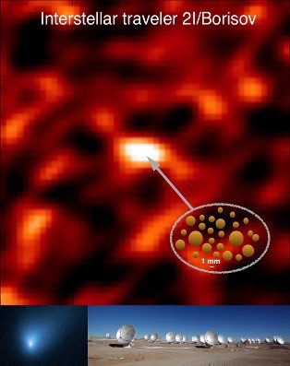
Large, compact pebbles of at least 1 millimeter in size were detected by ALMA in the first interstellar comet 2I/Borisov which traveled to the solar system from another star. Upper panel: ALMA map of the dust thermal emission of 2I/Borisov taken by Aigen Li and his collaborators on 2 December
2019. Bottom left: Hubble image of 2I/Borisov taken by D.C.
Jweitt on 12 October 2019. Bottom right: the ALMA
array consisting of 66 radio telescopes in the Atacama Desert of northern Chile, which observes electromagnetic radiation at millimeter and submillimeter wavelengths.

Creative Classroom

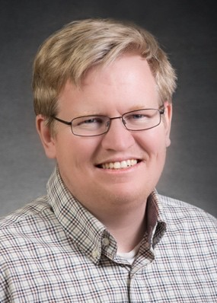
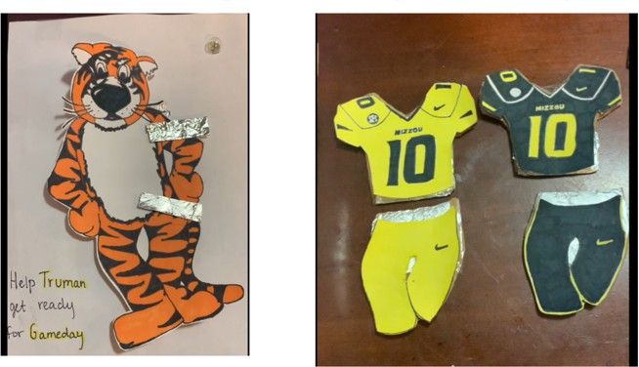
Professor Gavin King has been teaching Physics 1200 “Everyday Wonders: How Ordinary Things Work”, a new class geared towards non-science majors. The course, originally developed by former faculty member Dr. Karen King, has been offered for the past few semesters and covers topics ranging from “how does hair conditioner work” to “how does a metal boat float” to touch
screens and x-rays. The students complete two projects in the course, one of which is to create an electronic toy or game that would be fun for children to play with. The goal
is to interest non-majors in thinking like a scientist, including using mathematics and computational thinking, asking scientific questions, and engaging in argument

from evidence. An example of a past student project from the class is pictured on the right.
Mizzou Matching Game
Truman gets upset (light goes on!) if you don’t match the right outfit

Faculty News & Special Recognition


Professor Silvia Bompadre was recognized with two awards in spring 2021. She received the MU Outstanding Advising Award which recognizes two individuals (one MU faculty member and one MU staff member) who have demonstrated the qualities associated with outstanding undergraduate student advising. Professor Bompadre was also the recipient of this year's Blue Chalk Advising Award. The Blue Chalk Awards stand as some of the oldest forms of recognition for exemplary academic advising at MU. They allow the College of Arts and Science to highlight and publicly acknowledge its advisers who truly exhibit an investment in student development and success.

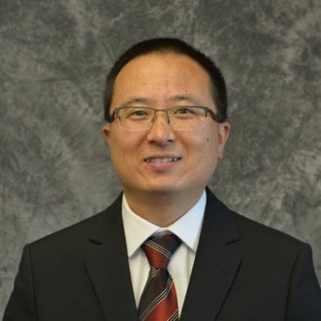
Professor Yicheng Guo received the 2021 Provost’s Outstanding Junior Faculty Research and Creative Activity Award awarded in June, which gives special recognition to junior faculty, who are in the early phases of their careers, for superior research and creative activity on the MU campus. Dr. Guo continues his research of using the data of the Hubble Space Telescope (HST) to understand galaxy formation and evolution. He is actively involved in two newly approved HST archival programs as co-PI and co-I, respectively.

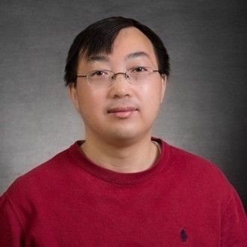
Professor Aigen Li has been named University of
Missouri Curators’ Distinguished Professor by the Board of Curators and announced by President Choi. Established in March 1968 by the University of Missouri Board of Curators, these prestigious positions are bestowed only upon outstanding scholars with established reputations. Professor Li and his collaborator Dr. J.W. Lyu of the University of Arizona were awarded 10.2 hours of James Webb Space Telescope (JWST) observing time to map the aromatic smoke from the superwind of the archetypal starburst galaxy M82. Scheduled to be launched in December 2021 and planned to succeed the Hubble Space
Telescope, the $10B JWST is NASA’s flagship astrophysics mission and will be the largest, most powerful, and complex space telescope ever built and launched into space. It will fundamentally alter our understanding of the universe.

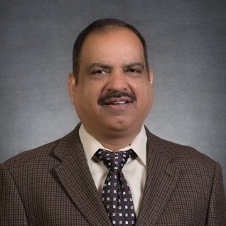
Professor Sashi Satpathy completed his six years' Department Chair term in Summer 2020 and has moved to full time research and teaching. Two members of the group completed their post-doctoral work and took up second post-doc positions, Dr. Sayantika Bhowal in ETH, Zurich and Dr.
Churna Bhandari in the Ames Lab, Iowa. Sashi received a Fulbright Fellowship from the Fulbright Foundation as well as a VAJRA Fellowship from the Department of Science and Technology, India, two separate prestigious awards, both for collaborative research with the Indian Institute of Technology, Madras. A new student, Tapesh Gautam, has joined the group.
The main work of the group is now focused on 2D materials including orbital Hall effect, strain effects, spin-orbit coupling, Skyrmion physics, and the new 1D CuO superconductors. New collaboration has been established with a number of institutions including Stanford University, Indian Institute of Technology, Madras, University of Ghana, and the National University of Singapore.

Authentisign ID: 4F24A8A5-D05D-ED11-ADE6-0050F2765AB1

Authentisign ID: 8B085C04-2Ae4--45!l8·A8 5-1C8E468B•,BE7

Missouri
ilE.., REALTORS

Amendment to Contract for Sale of Real Estate
This document has legal consequences. ff you do not understand it, consult your attorney.

AMENDMENT: To Sale Contract dated O c=t=o b e r 3 1 , 2 02 2 _
BY AND BETWE

2
3
- concerning real estate (the "Property") located at:

- 5443 State Hwy D
Street Address
Oak Ridge M0 _......:::6.::;37:..;6::.::9'-- ......:::C-=ac.pe=-=Gc.c.:ir-=accrd::..:ec.::a:c::u'----
City Zip Code County

- [Only those items completed below shall apply.]

7 _1
The date for Closing shall be changed from _
, to

- 2. The date for possession shall be changed from ,to
- 3. The date by which the following condition(s) must be satisfied shall be changed from
- to
- {a) _
- (b} _
- (c}
- 4. The following condition(s) shall be removed fi"om the Contract
15 (a_)
16 (b) _
i7 (_c)

1a 5, The Purchase Price shall be changed from $ 228,000.00 to$239,000.00
- 6. The Earnest Money deposit shall be changed from$ to$
- 7. The Contract is further amended as follows:
- George Rendleman shall be G1mrge P. Rendleman.
- Jo Ann Rendleman shall be Gloria Jo Ann Rendleman.

- IT IS UNDERSTOOD BY ALL PARTIES THAT ALL OTHER TERMS AND CONDITIONS
- OF THE CONTRACT REMAIN UNCHANGED.

r::ulhe :;:·


- 11/06/22 .....
28
1 · a M Godwin Revocable Trust
su:"..,2022 ._49_31f'M-c:fff-------------
Jr: ;:;1;;coT

29 u tJRl.,UW-J!Il.! J..L..,,_,,_"-'1-,'---------'-''-'-"'=-===-+
30
Judith Ann Green
31 Date: ; Date:

Approved by legal counsel for use exclusively by members of the Missouri REALTORS®, Columbia, fvUssourt No warranty is made or implied as to !he iegal validity or adequacy of this Amendmont, or that it complies in every respect with the lmv or that its use is appropriate fer all situations. Local law,
<:ustoms and practice, and differing circumstances in each transaction, may each dictate that amendmerils hereto be made.
Last revised 12/31/18. ©2018 Missouri REALTORS®

MSC-2000 Page 1 of 1

CF.!\"11.J 21.Mbhnd Re:alty{C:1pc), 1435 North '.\tr.Auburn R@dr Sni1t 200 Qpe Gir.1Tdettat )1063701 Phone:{57.3) -150-1620 Fax:{573) 472.-3?24
l.:tdonna Oo1ton Produced with L<me Wolf Transactioru:; (zipForm Edttion} 717 N HaT'l,-;ood St, Suite 2200. Dallas, TX 75201 www ty1p1t.com

Untilled

Faculty News & Special Recognition

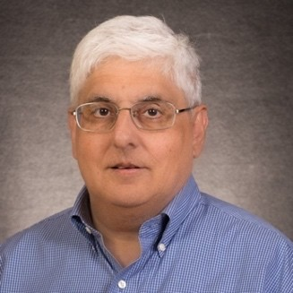
Professor David J. Singh was announced as a winner of the Charles Hatchett Award for 2021 for recent work on high performance piezoelectric materials. Introduced over 40 years ago, the Charles Hatchett Award is sponsored by CBMM | Niobium and recognizes the best published research on the science and technology of niobium. The annual award is supported by the UK’s Institute of Materials, Minerals and Mining (IOM3) and the winning paper is selected by a panel of international experts.

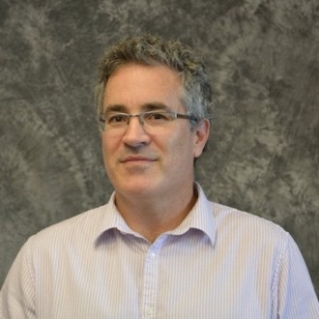
Professor Carlos Wexler was awarded an NSF Grant starting January 1: PFI-RP: Low- Pressure Storage of Biomethane and Power-to-Hydrogen in Alternative-Fuel Vehicles in collaboration with MST (Rolla). Within this project he also received an REU supplement to support undergraduate research in 2021-2023. He also directed remotely 2 MS Theses in 2020 and 2021 in the Erasmus Mundus Program “Chemical NanoEngineering” (part of an MOU between MU and University Aix-Marseille, France).

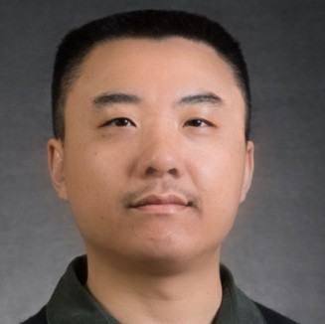
Professor Haojing Yan received the Chancellor’s Award for Outstanding Research and Creativity in January. This award gives special recognition to MU faculty members who are still in the developmental phases of their careers, have made outstanding contributions in research and/or creative activity and have great promise for achieving wider recognition.

(Continued from page 1, News from the Chair) `

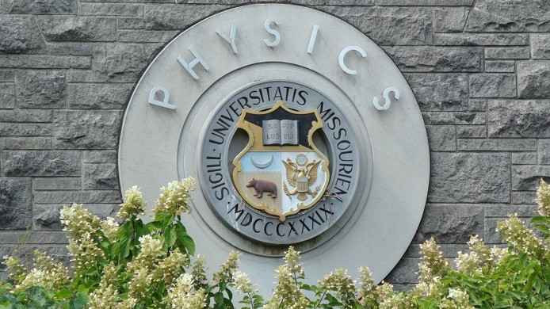
Many of our faculty have received recognition over the past year for their accomplishments in research and teaching. Prof. Silvia Bompadre was recognized by two MU awards for her outstanding advising: MU Outstanding Advising Award; and the Blue Chalk Advising Award. Prof. Yicheng Guo received the Provost’s Outstanding Junior Faculty Research and Creative Activity Award. Prof. Aigen Li was named University of Missouri Curators’ Distinguished Professor. Prof. Sashi Satpathy received two prestigious research awards: a Fellowship from the Fulbright Foundation and the VAJRA Fellowship from the Department of Science and Technology, India. Prof. David Singh received the 2021 Charles Hatchett Award for his winning paper on high performance piezoelectric materials. Prof. Haojing Yan received the Chancellor’s Award for Outstanding Research and Creativity. The Department is proud to congratulate all for their achievements.

In closing, I want to thank all of the faculty, staff and students for their enthusiasm and their hard work, which enables the Department of Physics and Astronomy to continue to be an outstanding place to learn and to do important research on the ABCs: Astronomy, Biophysics and Condensed Matter Physics.

4

Congratulations to Our Graduating Physics Majors

Departmental Honors requires > 3.5 GPA in physics courses, completion of 6 credit hours of research, and a publication or presentation (oral or poster).
Fall 2020
Kayla Hahn
Derik Russell, Department Honors
Zachary Yungbluth

Spring 2021 Ogonna Anunoby Lucas Chandler
Sean Cowell, emphasis in Materials Science Jonathan Hitchcock, emphasis in Astronomy John Lafevers
Zhongyi Li
Duy Tung Nguyen, emphasis in Materials Science, Department Honors
Alex Roush, Cum Laude
Seth Seagraves, emphasis in Astronomy
Matthew Snyder, Summa Cum Laude, emphasis in Materials Science, Department Honors
Matt Soehngen, Cum Laude
Andrew Tait, Magna Cum Laude, emphasis in Biophysics, Department Honors

A Certificate in General Honors from the MU Honors College requires students to complete 24 hours of courses for honors credit and maintain a 3.5 cumulative GPA.
To receive Latin honors from our College of Arts and Science requires at least 54 of the student’s last 60 hours at MU and:

  - – 3.799 GPA for Cum Laude
  - – 3.899 GPA for Magna Cum Laude
  - – 4.0 GPA for Summa Cum Laude

Graduate Degrees Conferred

Masters Graduates
Ph.D. Graduates:
Fall 2020
Fall 2020
Jared Williams Mari Tsumuraya
Edward Pluhar
Condensed M
atter Theory and Computation
Spring 2021
Travis Hurst Biological Physics
Summer 2021
Charles Mentzer
Co
ndensed Matter Phy
Aditya Putatunda
sics
Summer 2021 Lisa Sheppard Astrophysics

If you know a young high school student interested in a science career, there are many options with a degree in physics. Have them check out our department by using the contact information to the right, and https://physics.missouri.edu/undergrad/resources

To Visit the Department Contact MU Office of Admissions
230 Jesse Hall
Columbia, MO 65211-1300
phone: 573-882-7786
fax: 573-882-7887
email: mu4u@missouri.edu 5

Student Awards, Scholarships & Recognition

Many fellowships, scholarships, and other funds have generously been established and supported by our alumni. These students were the recipients of these funds and awards for the academic year 2020-2021 and summer 2021.

Graduate Student Scholarships
Undergraduate Student Scholarships

Paul E. Basye Undergraduate Scholarship
Nicholas Childers, Margaret Lyon, Ian Miller

Rose Marie Dishman Endowed Scholarship in Physics
James Lyerla, Kylee Willis

O.M. Stewart Scholarship
Robert Butler, Quinn Cunningham, Brandon Lee, Drake Sivils, Matthew Snyder, Andrew Tait, Corey Valleroy

Samuel S. Laws Scholarship
Lauryn Williams

Melvin Y. Mora Undergraduate Scholarship Fund
Lauryn Williams

Donald L. and Lona Lewis Packwood Endowed Undergraduate Scholarship Fund in Physics Justin Shotton

Clifford W. Tompson Scholarship in Physics
Cierra Presson, Kylee Willis

Carl & Brynn Anderson Graduate Student Award Fund in Physics
Todd Lombardi, Dylan Weaver

Rose Marie Dishman Endowed Scholarship in Physics
John Barron, Sean Fayfar

James L. and Dora D. Fergason Fund for Excellence in Physics
Dallar Babaian, Dillon Balthrop, Randy Burns, Todd Lombardi, Gourab Nandi, Mitchel Vaninger

Newell S. Gingrich Physics Scholarship Fund
Alex Bretana, George Yumnam

Newell S. Gingrich Physics and Astronomy Endowment
Vishal Jayswal, Charles Mentzer, Pratik Sahu

Guy Schupp Scholarship Fund
Lisa Shepard

Eli Stuart Haynes and Nola Anderson Haynes Scholarship Fund
Graduate Awards

Ron Boain and Catherine Rangel-Boain Dissertation Award
Alessandro Mazza, Alec Picket

We also want to acknowledge graduate student travel awards made possible by some of our generous alumni. The unique circumstances and restrictions of the past academic year and virtual meetings meant that no awards were made from the following funds:
Ron Boain and Catherine Rangel-Boain Travel Award Gerald Fishman Travel Award
Lisa Shepard

Ernest W. Landen Fellowship in Physics
Jiasen Guo, Dylan Weaver

O. M. Stewart Scholarship
Dallar Babaian, David Beckwitt, Payal Bhattacharya, Alex Bretana, Amarnath Chakraborty,
Alexander Daykin, Ehsan Faridi, Sean Fayfar, Pousali Ghosh, James Jones, Creighton Lisowski, Moudip Nandi, Deepesh Sigdel, Ryan Smith, Mari Tsumuraya

Our New Graduate Students

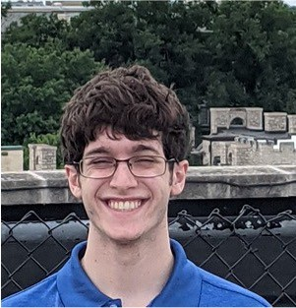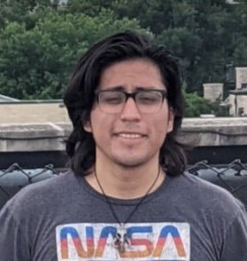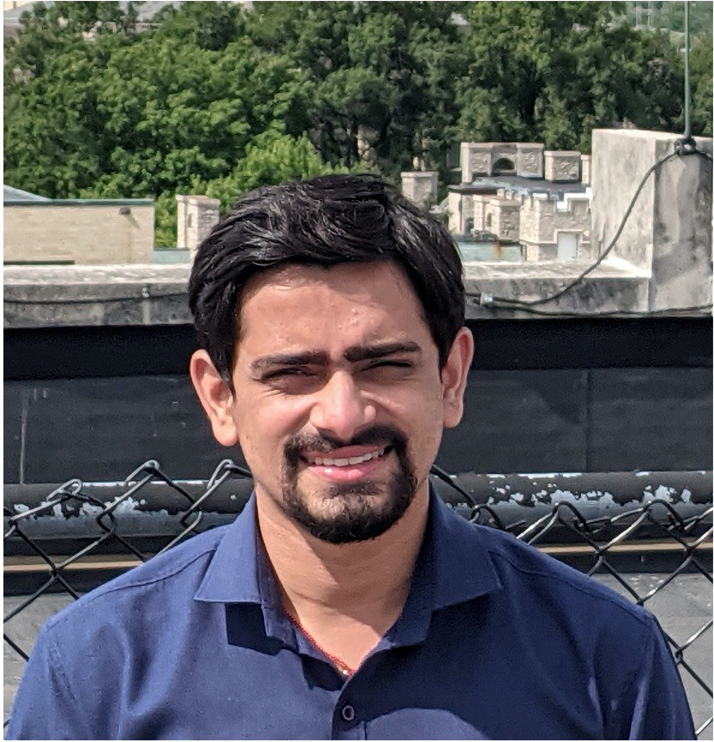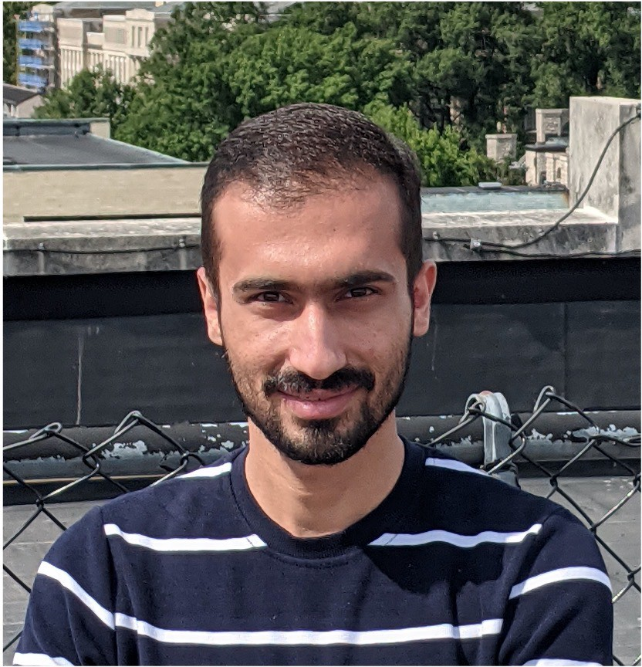

Dylan Chiaro
BS: Monmouth College, IL
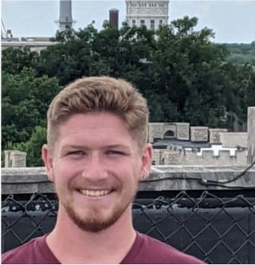
Aaron Guilliams
BS: Westminster College, Fulton
Harold Diaz-Quiroz BS: Illinois State U.
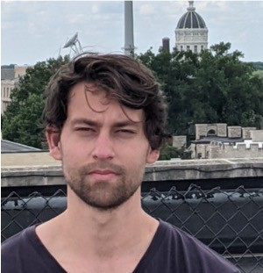
Stephen Klue MS: U. Western Cape,
South Africa
Tapesh Gautam MS: IIT Chennai, India
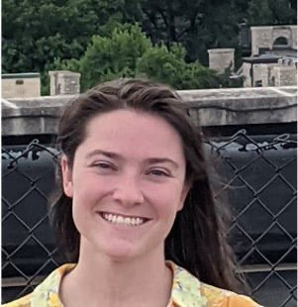
Vicki Kuhn MS: University of Minnesota Duluth
Aarash Ghobadi
BS: Semnan University, Iran
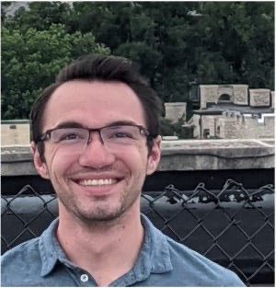
Connor Nance BS: Murray State University

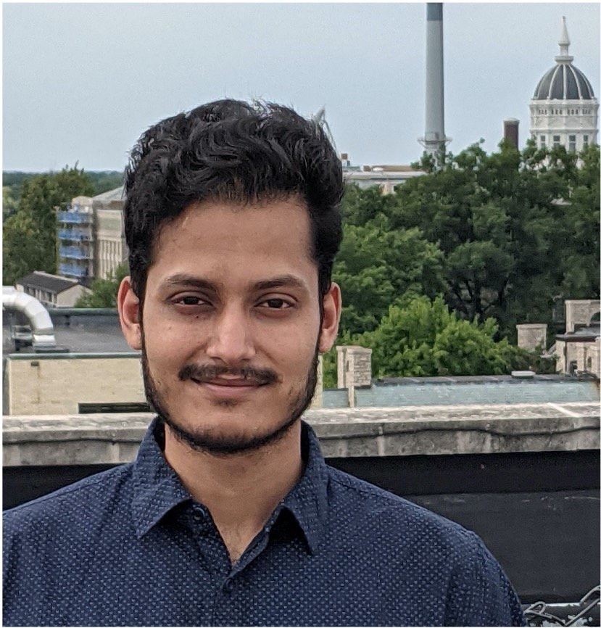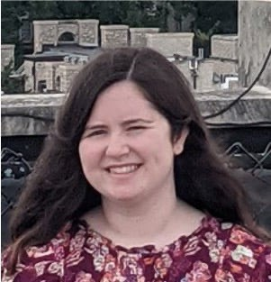

Gourab Nandi
MS: Univ of Kolkata, India (joined spring 2021)
Sadie Nickles
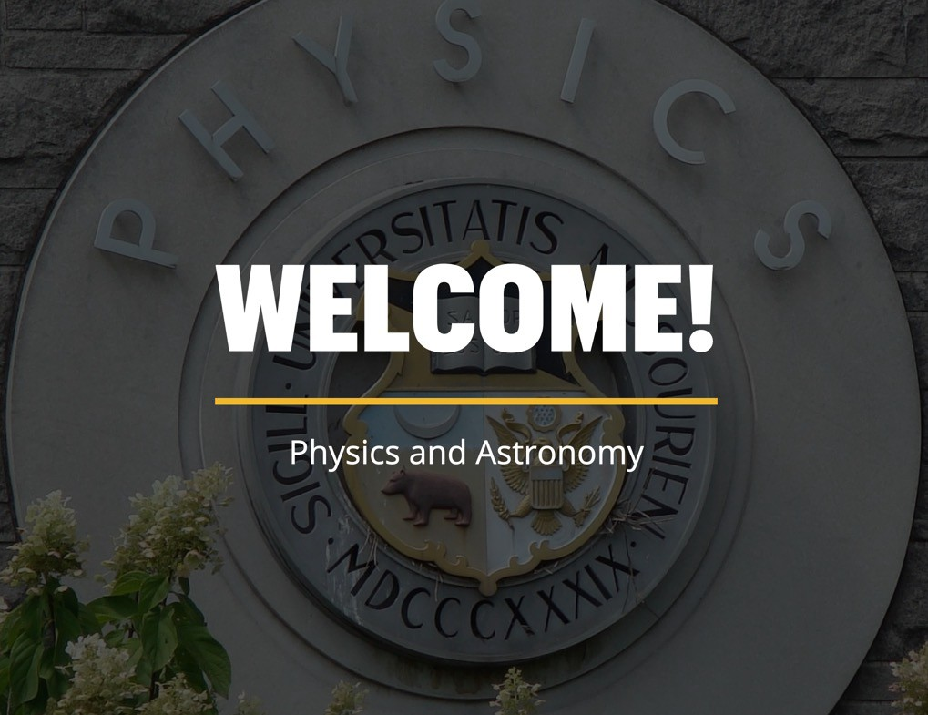
BS: Western Illinois U. Macomb

PAGSA News
The last year was difficult for PAGSA and even though our members couldn't gather in person we did our best to continue to foster the relationships built among our peers. We held meetings and journal clubs virtually, and even without the promise of pizza for showing up still had great turnouts! As restrictions start to lift our plans are to begin to (safely) gather in person again and hold events where graduate students can feel like they are part of a community. We had a welcome picnic this Fall for the new first-year students, and unofficially for the second-year students who didn't get to have a picnic last year as well. Coming up we will be participating in our first outreach event since the pandemic at Rock Bridge High School in November.
News contributed by Jared Williams, PAGSA president. Vice President is Charles Mentzer.

Undergraduate News and Accomplishments
Front row: Nicholas Childers (new inductee & vice-president), Emma Burton (New inductee & Treasurer), Cierra Presson (president). Back row: Matthew Dyer (past president),Ian Miller (new inductee), Brandon Lee (new inductee)
Society of Physics Students
The MU Society of Physics Students held online meetings over Zoom for the duration of the school year in light of the COVID-19 pandemic, with the exception of two in-person meetings following MU and public health guidelines at the end of the academic year. While this took away many traditional options for club activities, we pivoted to new online-friendly ones.

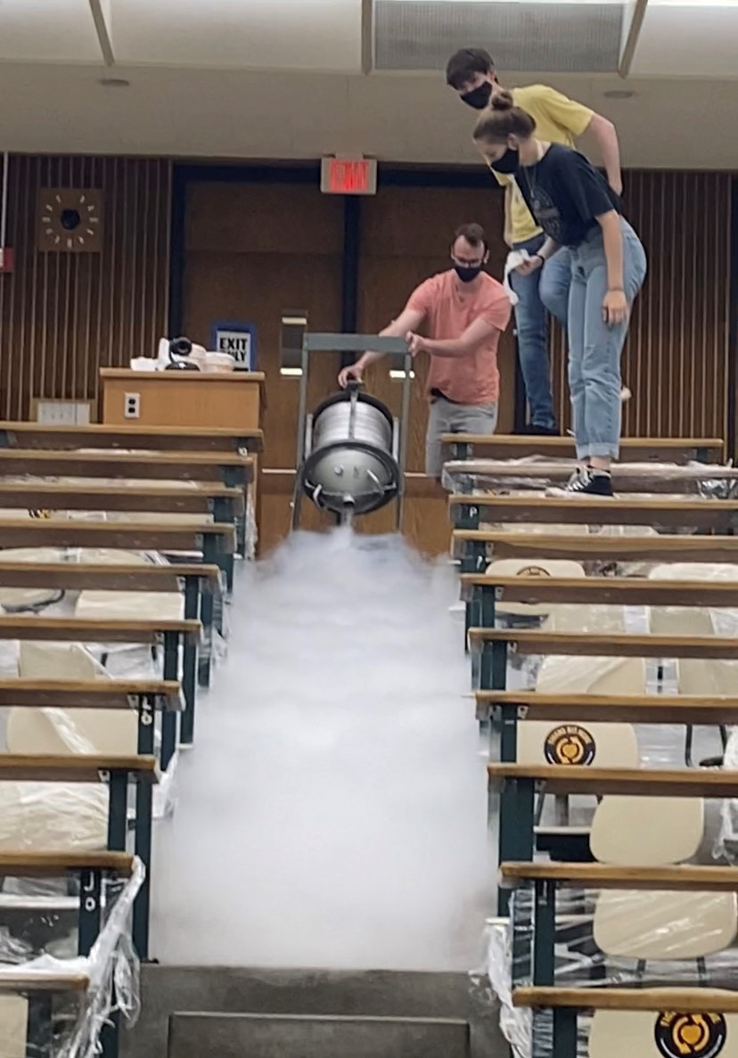
One crowd favorite was our Discord Game Nights on the Physics and Astronomy Discord server, which included Jackbox Games, Among Us, Pictionary, and more! We also gave presentations throughout the year, ranging from research presentations in topics like topological condensed matter physics, to the quantum Hall effect, to something as familiar as the Fourier series. We also worked with Sigma Pi Sigma to hold a graduate school preparation panel over Zoom and to promote undergraduate participation in research at MU. Our last two in-person meetings consisted of a liquid nitrogen demonstration with ice cream and a Physics Jeopardy! Trivia Session. We look forward to returning to 100% in-person meetings this year!

News contributed by SPS President Benjamin Krewson Vice President — Cierra Presson
Treasurer — Nicholas Childers
Secretary — Emma Burton What to do with the leftover liquid nitrogen after eating the homemade ice cream?

Enterprising physics students found a solution.

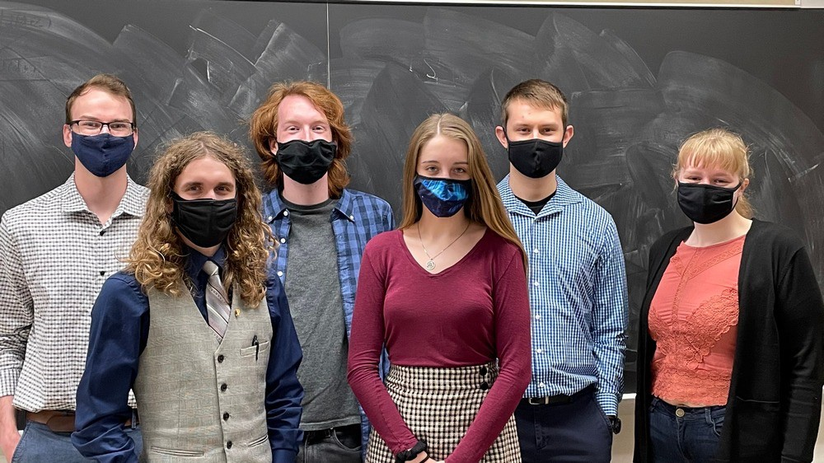
Sigma Pi Sigma

The local chapter of Sigma Pi Sigma, the honors physics society, inducted four new members on March 22, 2021.

We continue to hold meetings in conjunction with Society of Physics Students. In particular, we provide academic and professional development workshops, as well as resources for getting involved with research. We are planning the next induction for the spring semester 2022 to welcome new members. Sigma Pi Sigma is an organization of the American Institute of Physics, and a member of the Association of College Honor Societies. The mission of the MU chapter of Sigma Pi Sigma is to honor outstanding scholarship in physics, encourage interest in physics among students at all levels, promote an attitude of service of its members towards their fellow students, colleagues, and the public, and provide a fellowship of persons who have excelled in physics.

News contributed by Cierra Presson, Sigma Pi Sigma
President
Vice President - Nicholas Childers Treasurer - Emma Burton

MU Astronomy Club

The MU Student Astronomical Society is glad to be back meeting in-person! We meet every other Thursday from 6-7 PM in Physics Room 236 to chat about topics in astronomy that get us buzzing. Talks are usually geared towards all levels and majors.
Upcoming activities include Laws Observatory open nights which resumed normal operations this summer, a stargazing/astrophotography event the first week of October, and a stellar movie night to decompress after mid-terms. The photo below was taken at a star gazing excursion at Eagle Bluffs (south of Columbia) in March, 2021 by Nico Bohorquez (MUSAS Vice President) who has curated an extensive astrophotography portfolio.

News contributed by Emma Burton – MUSAS
President
Nicolas Bohorquez – Vice President Patrick Hayden - Treasurer
Gracye Allen – Secretary

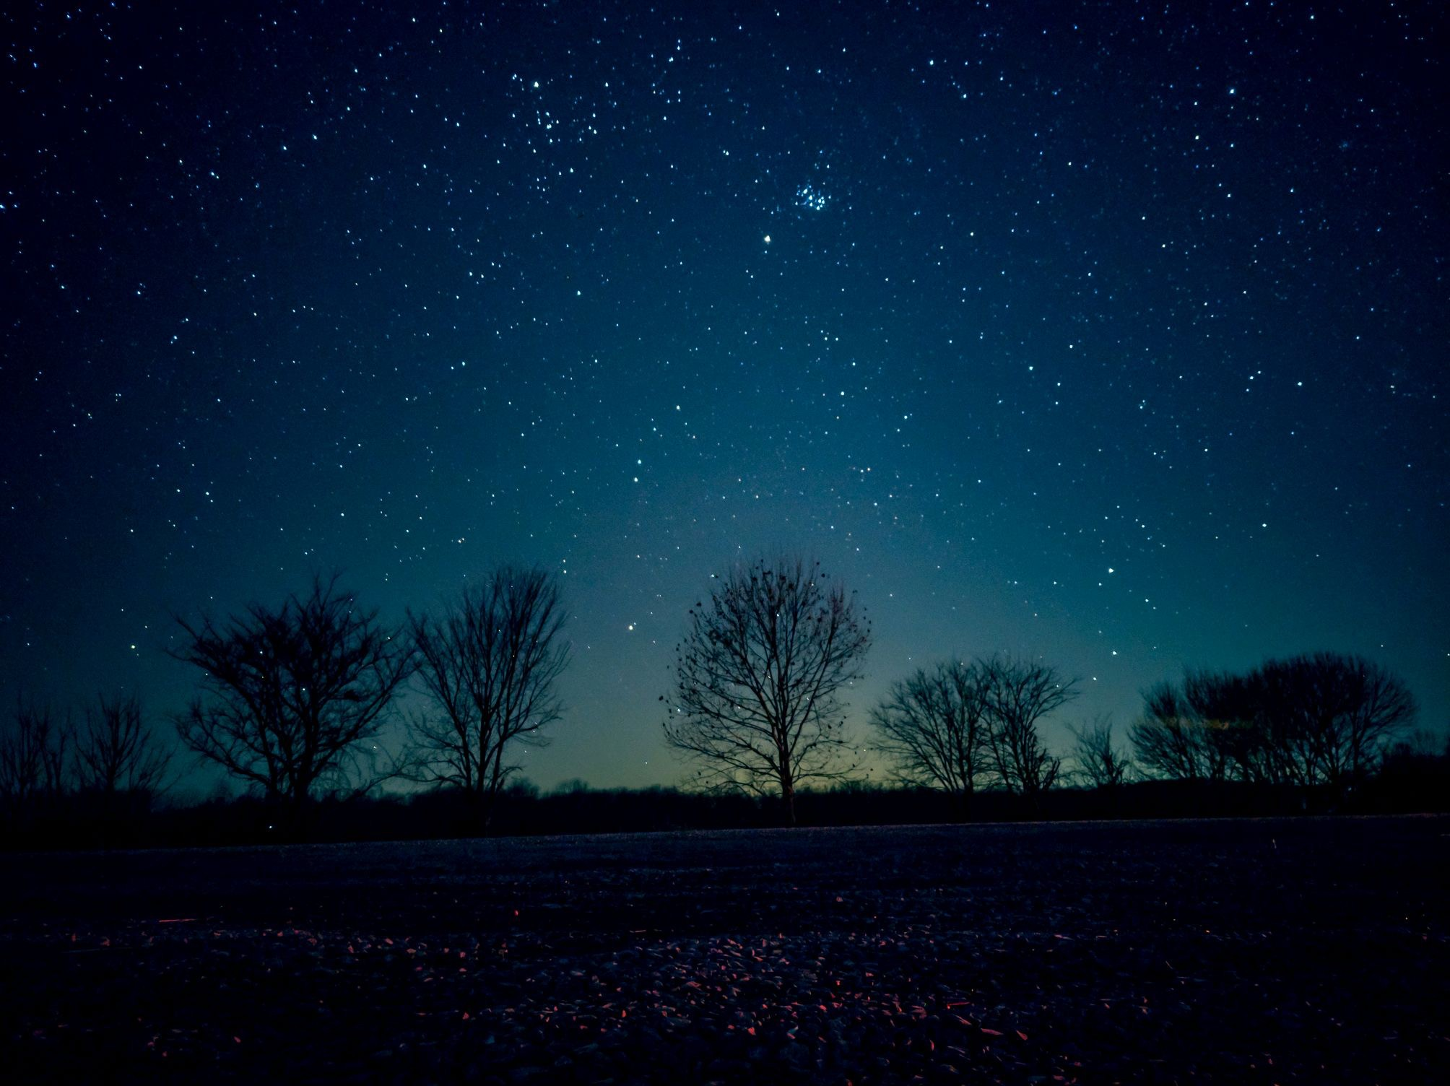
Pleiades (also known as the Seven Sisters or M45) can be seen in the upper middle of the the photo. Photographer: Nicolas Bohorquez

Laws Observatory

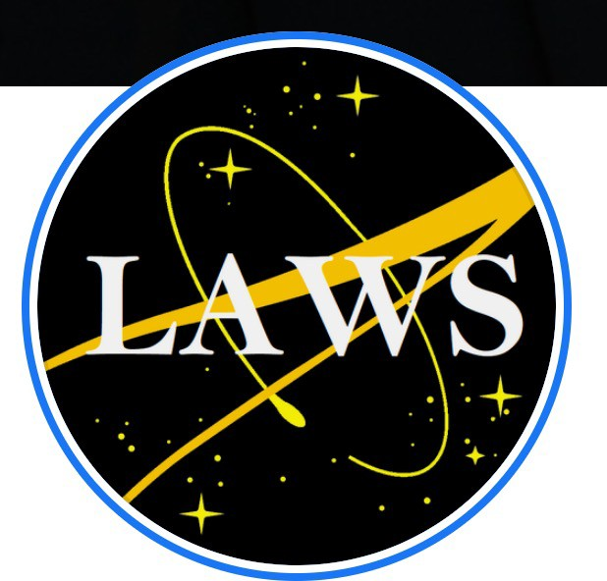
Laws Observatory on top of the Physics Building continues to be used for outreach and education. Wednesday night viewing for the public reopened this summer after being closed for much of 2020 and 2021 due to the Coronavirus pandemic. There were still a few special events as on December 21, 2020 when local station Channel 8 KOMU covered a live streaming of the Jupiter-Saturn conjunction.
Central Missouri Astronomy Association member Valentine Germann, department alumnus Ronald Boain, and professors Yicheng Guo and Haojing Yan were on site for the event.
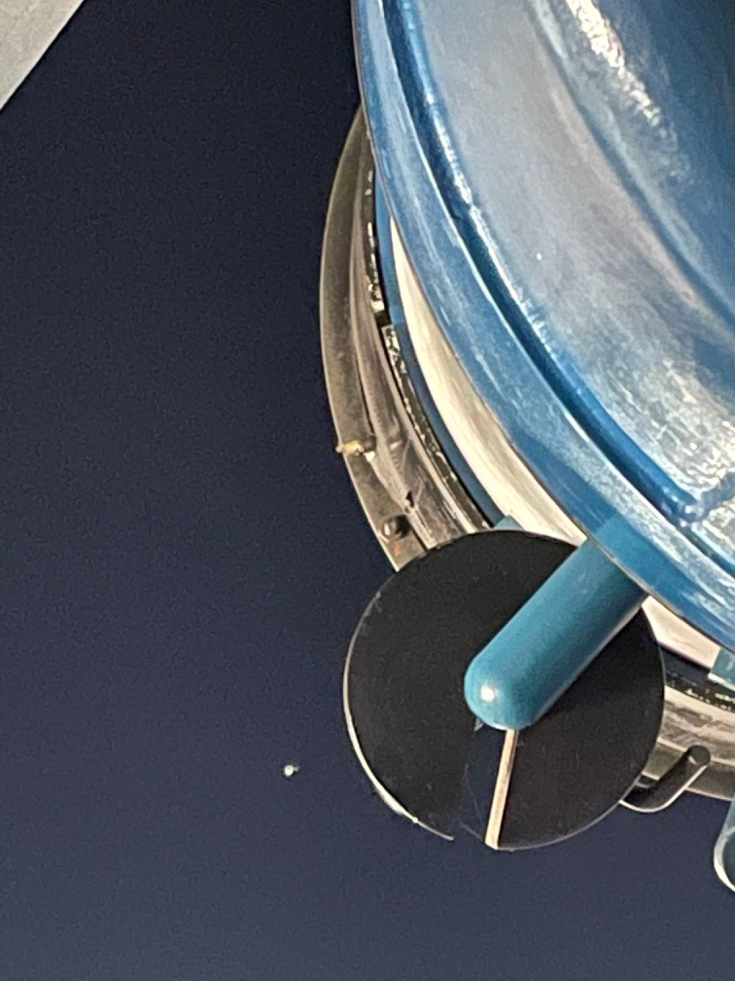
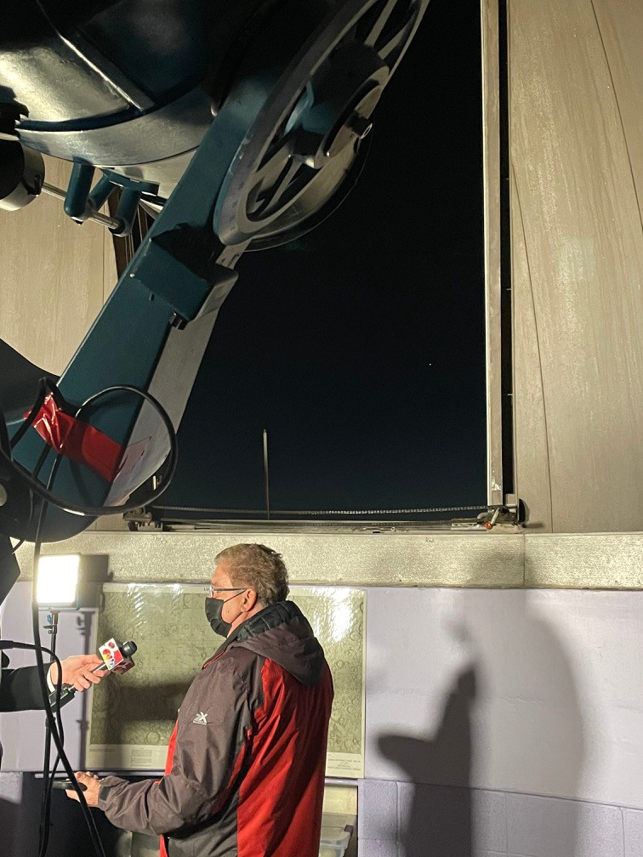
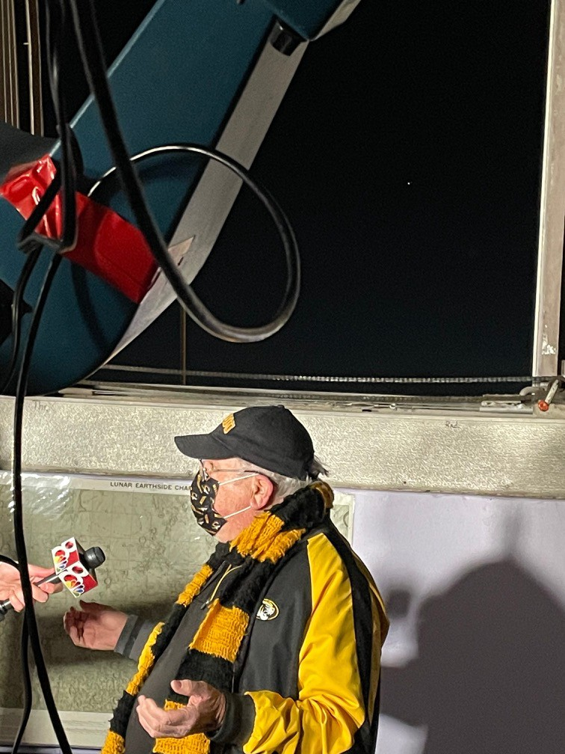
pictured: Telescope, Valentine Germann and Ronald Boain
photos by Haojing Yan

Alumni Focus
We invited department alumnus Ronald Boain to share details of his very interesting career, considering it to be of interest to our students as well as to other alumni. We welcome other alumni profiles and will share on our website. Please email us (see contact info at the end) if you would like to share your story.

A Career Path Less Often Travelled By Ronald Boain, B.S. and M.S. Physics,
University of Missouri

"This essay is a recounting of my life's path, beginning from when I was a student at the University of Missouri to working in the aerospace industry and eventually at the Jet Propulsion Laboratory; this path was not a straight line but had many twists, turns and decisions. However, in the end, everything worked out well for me, because I had a good foundation provided by my university education.
As a graduate student in 1965-67, it seemed to me that the majority of physics majors saw their futures as university teachers and/or professors. Few, if any, seemed to be interested in non-academic fields or industry careers. I wasn't much different in that I aspired to becoming a professional astronomer doing teaching or research. In my mind by studying physics and taking every astronomy course offered by the department, I could finish my PhD degree and become an astronomy instructor at a college or university. But external factors affecting my life made me rethink this midway through my second year of graduate studies. Among these factors were my financial situation (desperately poor and not wanting to take loans) and the fact that my wife and I were expecting a child. On top of that, my draft board was threatening me with military service by reviewing my status as a student every semester (one must remember that 1967 was the height of the Vietnam war). Also, I was keenly aware, as possible opportunities for me, of the ongoing "space race" to the moon between the United States and the Soviet Union and NASA's incipient ventures in planetary space exploration.
Although I had passed my qualifying exams allowing me to continue working for a PhD, I decided to end my academic career after finishing my M.S. degree. Fortunately for me, jobs were plentiful at that time for anyone with a technical degree. In the spring of 1967, I accepted a job offer at Boeing's aerospace company in Seattle working on their space defense efforts. The defense work had the side benefit of guaranteeing me a deferment from the draft.
So it was that I moved to Renton, Washington in the suburbs of Seattle that summer. Ironically, my time at Boeing was to be short because soon after I arrived, Boeing's fortunes immediately began to decline due to the loss of several major contracts. This opened my eyes to the vagaries of working in the aerospace industry as it was in 1967. I immediately began searching for another, more secure job which ultimately landed me in Houston, Texas working for TRW (a now defunct aerospace company) on the Apollo Program's manned moon mission.” Continue reading Ron’s story at https://physics.missouri.edu/physics-leaders

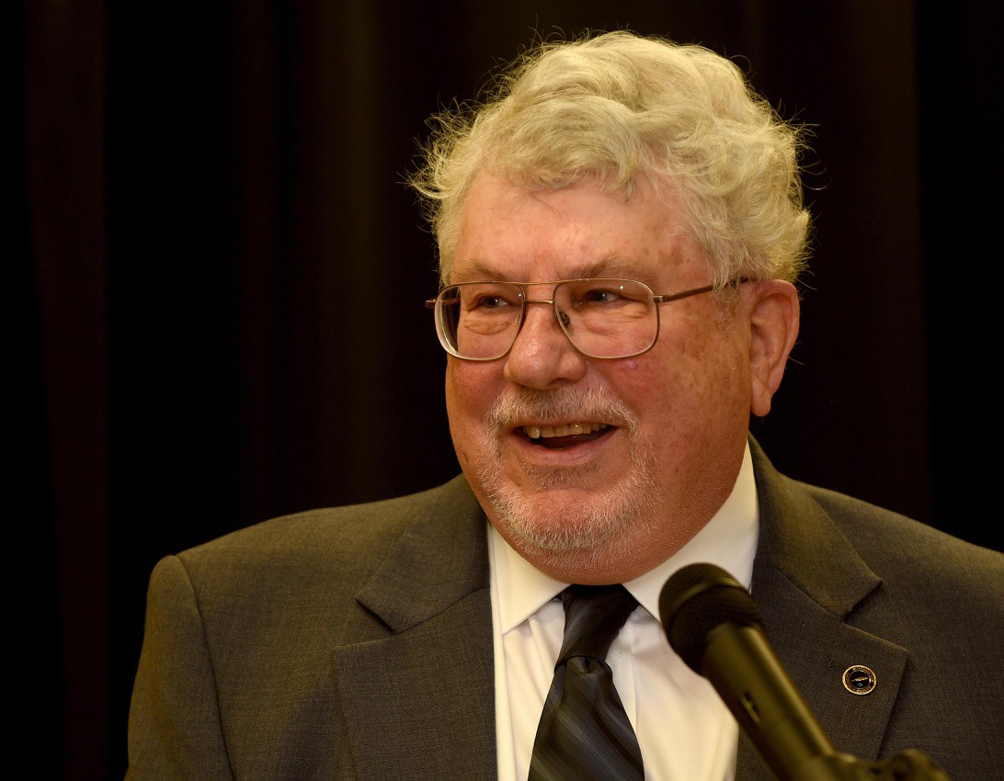
Ron went on to work as a NASA contractor on the Apollo Program in Houston, TX, doing trajectory contingency analyses helping us get to the Moon. He then moved on to Martin Marietta Aerospace (now Lockheed Martin) near Denver, Colorado and eventually landed a career at NASA's Jet Propulsion Laboratory for 40+ years that led to becoming a Project Systems Engineering on CloudSat, still functioning in orbit, and a project to which he still contributes his expertise. There is a lot more to his story – please visit our website physics.Missouri.edu and navigate to People/Physics Leaders, or type in: https://physics.missouri.edu/physics-
leaders to read the rest of his story. Ron Boain

2020 Physics Leaders Meeting

Due to the pandemic and university restrictions the usual two-day fall Physics Leaders meeting was converted to two single-day virtual meetings on November 14, 2020 and April 10, 2021. The fall meeting consisted of usual department report by chair Dr. Paul Miceli, Suchi Guha, Director of Graduate Studies and Silvia Bompadra, Director of Undergraduate Studies. Dean Pat Okker also joined us virtually to discuss the college of A&S.
The annual department awards were presented virtually:

Faculty Recognition Award Recipients
Sashi Satpathy David Singh Giovanni Vignale

Ronald J. Boain and Catherine J. Rangel-Boain PhD Dissertation Awards
Alessandro R. Mazza (now postdoctoral researcher Oak Ridge National Lab)
Alec Pickett (now at Intel Corporation)

2020 Department of Physics & Astronomy Distinguished Alumni Award
Our department Distinguished Alumni Award for Lifetime Career Achievement was presented to Donald Packwood, Ph.D. 1971, for his career excellence and contributions to our department. Highlights include a distinguished career at Hewlett-Packard Corporation in semiconductor research where he advanced to an engineering manager position, being a founding member of the Physics Leaders and second president of the group, receiving the MU A&S Distinguished Alumni Award in 2004, and receiving an honorary professional degree in physics from UMR (now MU S&T) where Don received his undergraduate degree.

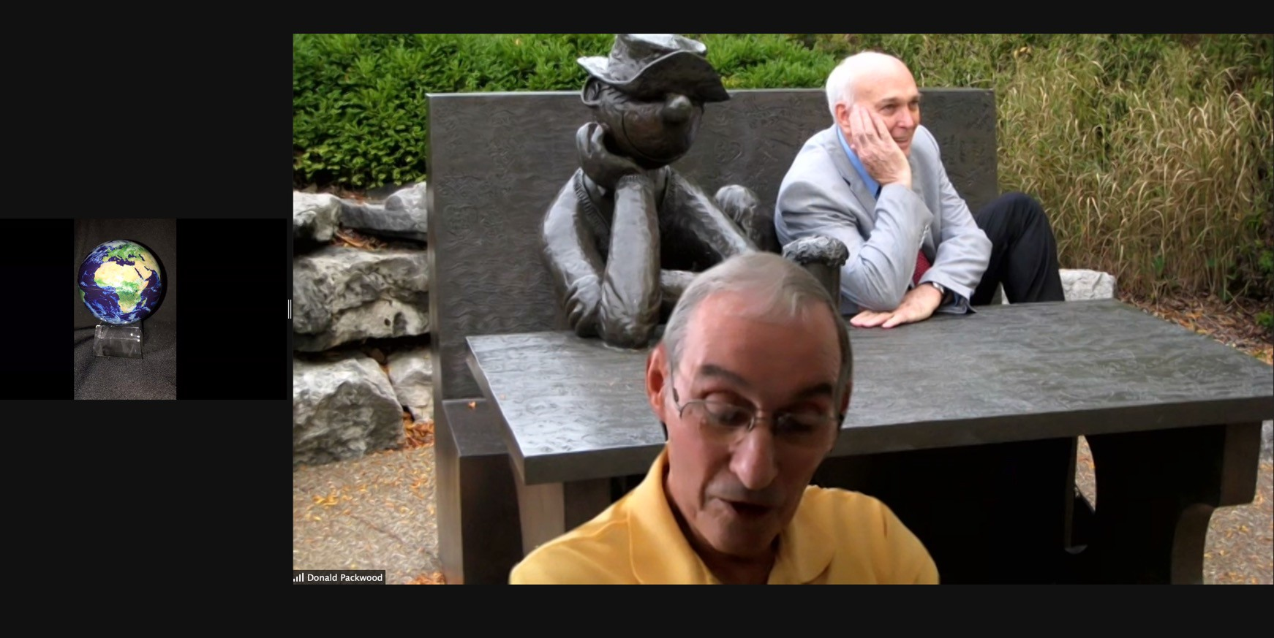
Don Packwood, with award on the left, accepting the award and reminiscing on his career. The clever zoom background includes department alumus and former alumni award recipient Gerald Fishman in a photo taken in front of the MU Alumni Center.

The spring meeting focused on our student presentations to the leaders. Four undergraduate and four graduate students participated; all presentations were outstanding. The leaders selected the following first and second place awardees:

Undergraduate
First place: Rory Butler (Advisor: Prof. Suchi Guha) for “Magnetic Field Dependence of the Optical Properties in Lead Halide Perovskites”

Second place: Matthew Snyder (Advisor Prof. Guang Bian) for "Monte Carlo Studies of Nontrivial Defect Boundaries in an Ising Model Magnet"

Graduate

First place: Alex Bretana (Advisor: Prof. Wouter Montfrooij) for “The Appearance of Spontaneous Disorder in Disorder- free Systems”

Second place: Ryan Smith (Advisor: Prof. Ioan Kosztin) for "Energetics and Kinetics of Peptide-Lipid Membrane Interactions: A Molecular Dynamics Study”


College of Arts and Science
Department of Physics and Astronomy University of Missouri
Communiqué is published annually by the Department of Physics and Astronomy at the University of Missouri.

Editorial Oﬃce
Department of Physics and Astronomy 223 Physics Building
Columbia, MO 65211
Phone: 573-882-3335
E-mail: umcasphysics@missouri.edu Web site: physics.missouri.edu

Editorial Board Linda Godwin Dorina Koszrn Paul Miceli

The department appreciates hearing from alumni and friends. Send announcements or milestones to the address listed above.
223 Physics Building
Columbia, MO 65211



Check us out on Facebook: https://www.facebook.com/MUphysics
Update your contact information, through the MU Alumni Association website: website: http://www.mizzou.com/.
You do not need to be a member to update your information.

Do you know a department alumnus that you want to nominate for a Department of Physics & Astronomy Distinguished Alumni Award? Visit this website for more information:
https://physics.missouri.edu/alumni-and-giving

We welcome career profiles of our alumni - email us
at umcasphysics@missouri.edu with your story and we will include it on our webpage.

Department news: https://physics.missouri.edu/news
If you didn’t also receive this newsletter via email , please update your email address at http://www.mizzou.com (Alumni Office)

